Print hello world on LCD screen

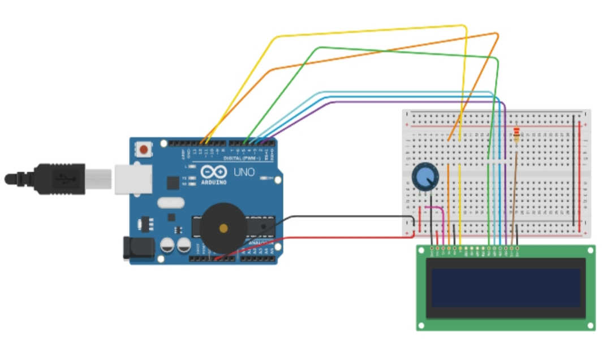

THEORY

Concept used :- connecting lcd to aurdino

Observation :- I have observe that we can print to many thing on lcd we can also print image on them

Problem and troubleshooting :- the main problem was this circuit consist of too many wires in it . It become hard to connect them on breadboard

Precaution :- take good brief on circuit diagram.

Outcome :- we can make bulleton board fom them .